**prep week markdown Maria Dahmosh**

1. What is Markdown, and why is it useful for web development?

Markdown is a lightweight markup language that you can use to add formatting elements to plaintext text documents.

Markdown is an easy-to-read, easy-to-write language for formatting plain text. You can use Markdown syntax, along with some additional HTML tags, to format your writing on GitHub, in places like repository READMEs and comments on pull requests and issues.

1. How do you create a heading in Markdown?

To create a Heading, add number signs ( # ) in front of a word or phrase. The number of number signs you use should correspond to the heading level.

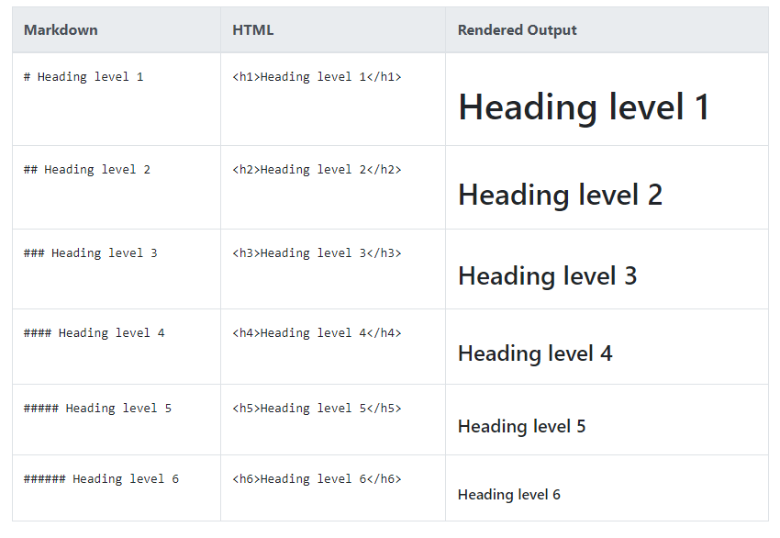

1. Explain how to make text bold and italic in Markdown.

Bold Text: **text** or __text__ (underscore)

Italic Text: *text* or _text_

Bold & Italic: ***text*** or___text___

1. What's the syntax for creating an unordered list in Markdown?

To create an unordered list, add dashes ( - ), asterisks ( * ), or plus signs ( + ) in front of line items.

1. How can you create a numbered list in Markdown?

You can make a numbered list by starting each line with a 1. followed by a space.

You can replace the number it doesn't affect the output.

1. Describe how to insert a hyperlink in Markdown.

In Markdown, a link is created by enclosing the link text in square brackets, [Link text], and then following it immediately with the URL in parentheses, (URL).

[What the link will display] (URL)

1. How do you add an image to a Markdown document?

Images in Markdown can be created by inserting the image name inside the square brackets and image link URL inside the parenthesis with an exclamatory symbol at the beginning.

![image ALT text] (URL)

1. What's the Markdown syntax for creating a horizontal line or separator?

To create a horizontal rule, use three or more asterisks (`***`), dashes (`---`), or underscores (`___`) on a line by themselves.

--- / ___ / ***

1. How can you escape special characters in Markdown?

To escape characters, prefix them with a backslash (\)

1. Explain how to create inline code in Markdown.

To create inline code, wrap with backticks ` .

1. What is a blockquote, and how do you create one in Markdown?

If you need to call special attention to a quote from another source, or design a pull quote for a magazine article, then Markdown's blockquote syntax will be useful. A blockquote is a sentence or paragraph that's been specially formatted to draw attention to the reader.

To create a block quote, all you have to do is preface a line with the "greater than" caret (>).

1. Describe the Markdown syntax for creating tables.

To add a table in Markdown, use the vertical line | to separate each column, and use three or more dahses --- to create each column’s header. A vertical line should also be added at either end of the row.

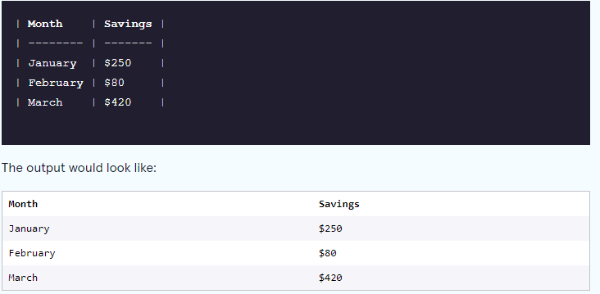

1. How can you create a code block or fenced code block in Markdown?

To create a code block, either indent each line by 4 spaces, or place 3 backticks ``` on a line above and below the code block.

1. What are backticks (`) used for in Markdown, and how do you escape them if needed?

Backticks ( ` ) denote a word or phrase as code.

To include a non-code formatted backtick it can be added by escaping it with a \.

\`

Or

Wrapping inline code blocks in double backticks instead of single backticks allow a backtick to be used.

`` ` ``

1. How do you create a task list or to-do list in Markdown?

 To create a task list, add dashes ( - ) and brackets with a space ( [ ] ) in front of task list items.

1. Explain the purpose of Markdown extensions like GitHub Flavored Markdown (GFM).

GitHub Flavored Markdown, often shortened as GFM, is the dialect of Markdown that is currently supported for user content on GitHub.com and GitHub Enterprise.

he purpose of Markdown extensions like GitHub Flavored Markdown (GFM) is to enhance the functionality of Markdown for specific platforms, such as GitHub, by adding features like task lists, issue references, tables, and improved rendering for better collaboration and formatting options.

1. What is the purpose of a Markdown editor, and can you recommend any popular ones?

The purpose of a Markdown editor is to provide a user-friendly interface for creating, editing, and previewing Markdown documents. These editors typically offer features such as syntax highlighting, live preview, and easy export options to various formats like HTML or PDF. Markdown editors streamline the writing process and make it easier for users to produce well-formatted documents without needing to memorize Markdown syntax or switch between multiple applications.

I recommend for visual studio code.

1. How do you add comments or annotations in Markdown?

Markdown doesn't include specific syntax for comments, but you can add comments or annotations using HTML comment tags.



1. Describe the concept of Markdown rendering and how it affects the final output.

Markdown documents are not pre-processed, meaning that they are written, storred, and transferred as they are. A Markdown Renderer receives the plain text content directly. Then, the renderer would be responsible for converting the text into a structured document.

1. How can you include emojis in your Markdown documents?

* Emoji Shortcodes: Type : followed by the emoji's name to bring up an autocomplete menu. For example, :smile: inserts a smiley face.
* Emoji Picker: Use the emoji picker in your markdown editor, typically accessible via a smiley icon, to insert emojis into your text.